CPCS-433

Submitted by
Yasser Kaoor – 1741264
Supervisor
Dr. Turki Talal

Faculty of Computing and Information Technology
King Abdul Aziz University

Data Selection

In this project there are three datasets for classification. In the table below there are some information about the data set.
Dataset | Area | Number of Attributes | Number of Instances
default of credit card clients | Business | 24 | 30000
Online Shoppers Purchasing Intention | Business | 18 | 12330
South German Credit | Business | 21 | 1000

Data Preprocessing

Before Data Manipulation step, a necessary preprocessing for data shall be achieved. In the project, the group have made the following edits to the data:
1.All datasets were in .csv file extension but credit card file was in .xls , the group found that it would be easier to convert the datasets to .txt instead for easy manipulation in the code.
2.Removed the header info of each dataset.
3.Removal of whitespaces and separating it via commas and not spaces.
4.Changes in Online dataset:
- Change label from TRUE and FALSE to 1 and 0.
- Make months by numbers.
- Make visit by number.

Data Mining

The following are the series of steps taken in order to build the classification models in the project.
1.For Cross Validation, the k for folds have been initialized as k = 5 as in 5 folds.
2.As mentioned earlier, there are four datasets in the project and there are four classifiers that will be worked on each dataset. The four classifiers are:
a. Adaboost.
b. Random Forest.
c. SVM.
d. XGBoost.
And how the project structure is worked on is by dividing each dataset to four blocks Since all datasets will be implemented in the same way and structure (with the exceptions of identifying variables and datasets), the following will show how a dataset (Credit_card) have been divided by four classifiers. Starting with Adaboost.
a. Declare creditCard_folds for storing kfold for Credit_card’s dataset.
b. Declare variables for performance measure (ACC, BAC, F1) and for TPR and FPR for Credit_card’s Adaboost.
c. Inside a for loop, divide train and test for Credit_card’s Adaboost sets.
d. In the training for Credit_card’s Adaboost, the last column will be converted to character to compare the tuples and check if it’s == “1” then +1 and if it’s == “0” then -1. and store it as numeric in y and put the whole data in matrix except last column in x.
e. Apply Adaboost function with the x and y taken from above.
f. Same thing that was being done in training shall be done in testing except for the change of train set to test set as well as removal of fit’s Adaboost function.
g. Prepare data from prediction and apply confusion matrix to generate tp, fp, tn, fn.
h. Calculate both TPR and FPR this equation tp/(tp+fn) and fp/(fp+tn) respectively.
I. Calculate all performance measures. (ACC, BAC, F1)
j. Output the mean and standard deviation of each performance measure for Credit_card’s Adaboost.
And this concludes the implementation of the first classifier on a dataset.
3.Second classifier is Random Forests, which will follow the similar steps to what’s shown above for Adaboost except some minor changes in the train and test sets. Make y as factor and x as the whole data except the last column and applying both as parameters in Random Forest function. the same thing in the test with the exception of the function.
4.Third classifier is SVM, which will follow the exact same steps shown above for Adaboost except some minor changes in the train and test sets in x. SVM’s function will include x and y and a “scale=TRUE” parameter.
5.Last classifier is XGBoost, same steps as Adaboost except for minor changes in the data checking results “1” = +1 and “0” = 0 instead and the XGBoost function apply x and y as data and label respectively, apply nrounds = 4 which are the number of passes of data that improves cross validation, and lastly apply objective = “binary:hinge”.
This concludes implementation of all classifiers in a dataset, now the same steps taken will be applied for the other three datasets.
6.After finishing the Cross Validation phase, start the statistical test specifically the Friedman Test and Bergmann-Hommel Post Hoc Procedure. The test will be applied on all three performance measures from all datasets and comparing them based on the four classifiers.
Calculate the mean of acc and mean of bac and mean of f1 and add each one of them to it’s specific dataframe and run the statistical test on them.
- CreditCard
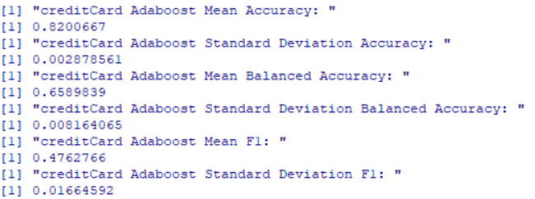
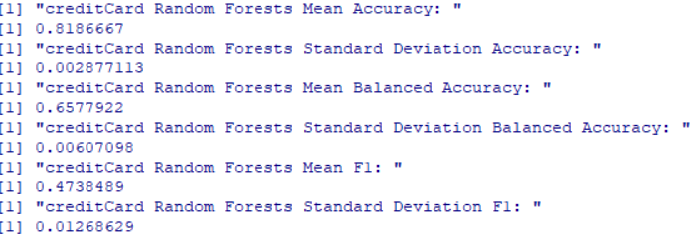
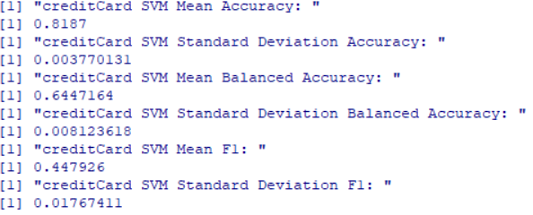
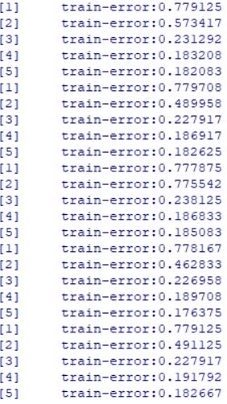
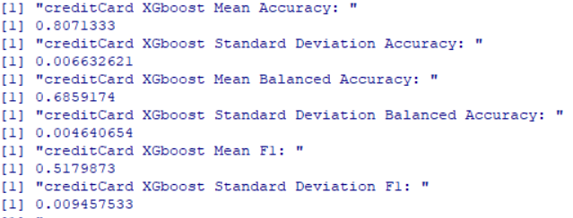

2-southGerman
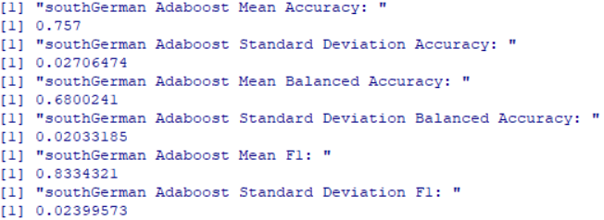
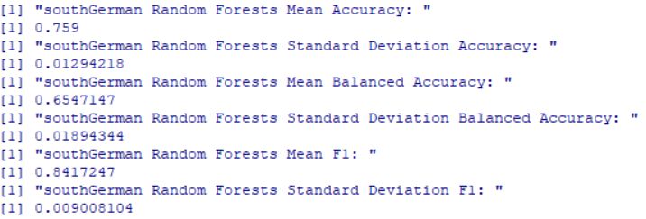
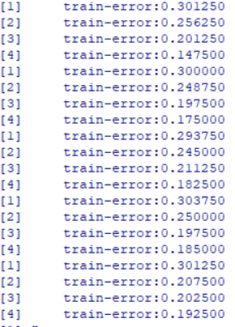
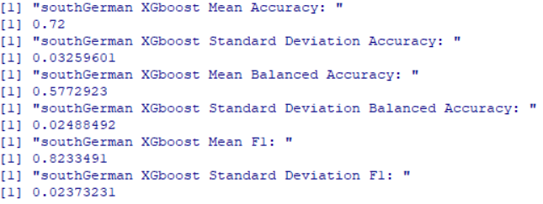
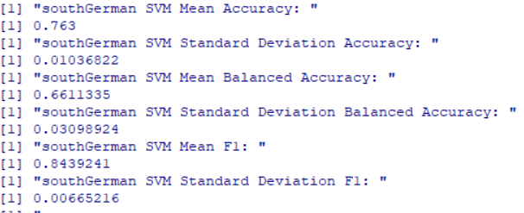

3- online_shop
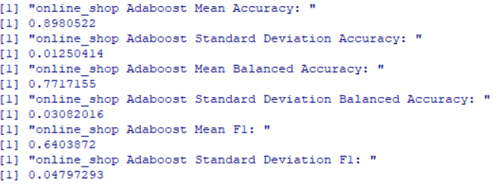
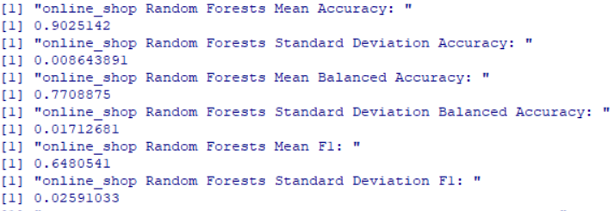
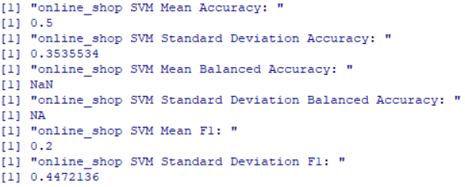
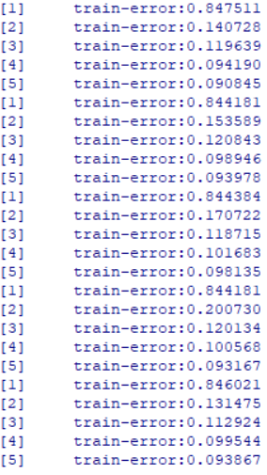
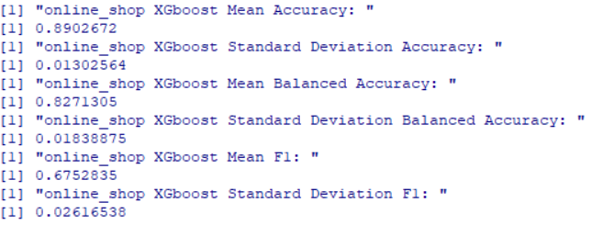

DATA and Labels datasets are too heavy so it is very difficult to debug it and the main problem with it that the row and column can not be bind together because of the different number of rows.

Evaluation

